IIITD&M Kancheepuram

**Problem solving and programming**

**Date: 24 JAN 2021**

**Duration: 01 Hr. Total Marks: 20**

1. What is the output for the following program? If there is an error, does it occur at compile time or run time? Also, modify the program such that output is: abd.

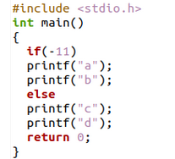

1. How many times is hello printed? Which printf statements are being executed. Give reason for your answer.

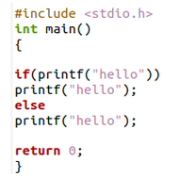What is the difference in the output between program (a) and program (b)? Give reason for your answer.

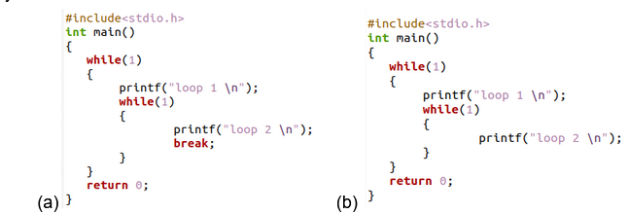

1. (123) base 5 = (X8) base y . Find the possible values for X and Y.
2. Convert the given number (657) base 8 to hexa decimal no
3. Find 2’s complement representation for the decimal number -2502
4. Find the values of the following considering a=45, b=53 and also give the truth table for operators respectively(provide your answer in binary as well as decimal format):
   1. a&b
   2. a|b
   3. a^b
5. Which of the following cannot be a variable name in C?

a) volatile b) true c) friend d) export e) register f) extern

1. Initial values of x, y, z are 1,5,10 respectively. Later

x=y==z; y= (y++)+x; z=(++x)+y+z

What would be the final values of x, y, z respectively after executing the above statements

1. Which of the following declarative statements/ initialization are syntactically incorrect and why (a) int x,y,x; (b) int a1,2,3; (c) unsigned int x=12, y=-23; (d) float x=10, y=x+2;